

**August 11, 2017**

Technical specification document –

Database Restore/Refresh (Non-Production)

# INTRODUCTION

# Objective

Script to restore Non-Production database (NGTest, NGDEVL and NGDEMO)

# Scope

Script to run manually as per the requirements.

# Functionality

Script designed restore “Non-Production” database.

**Step 1 –** Run the following script to restore non-production databases (NGTest, NGDEVL and NGDEMO)



**Step 2 –** Once restore is completed "**Set Database**" in Nextgen, Screenshot Below.

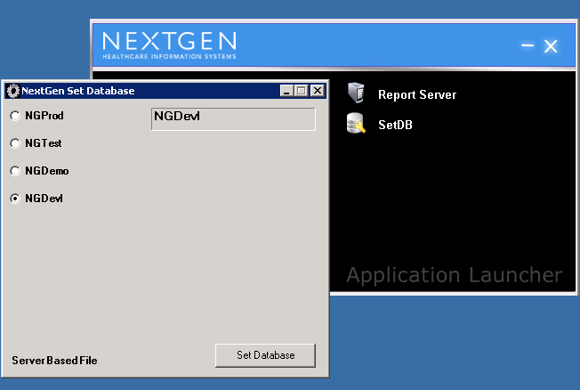

**Step 3 –** Update Nextgen License as per the Database

* Open Below window as per the path “**C:\Nextgen\NGLicenseManager.exe**”
* Click on apply and copy attached license key and past on below window and then click on validate then click on ok button.
* License should be latest as per the database.(Example



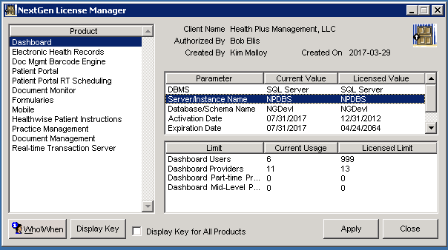

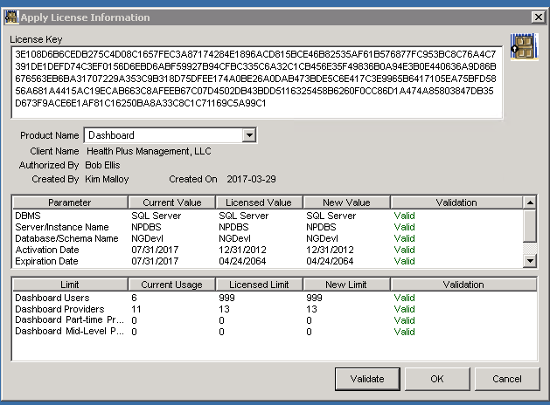

**Step 4 –** Update universal path as per the database using below script



**Step 5 –** Change Recovery mode to simple and shrink database using below script.

